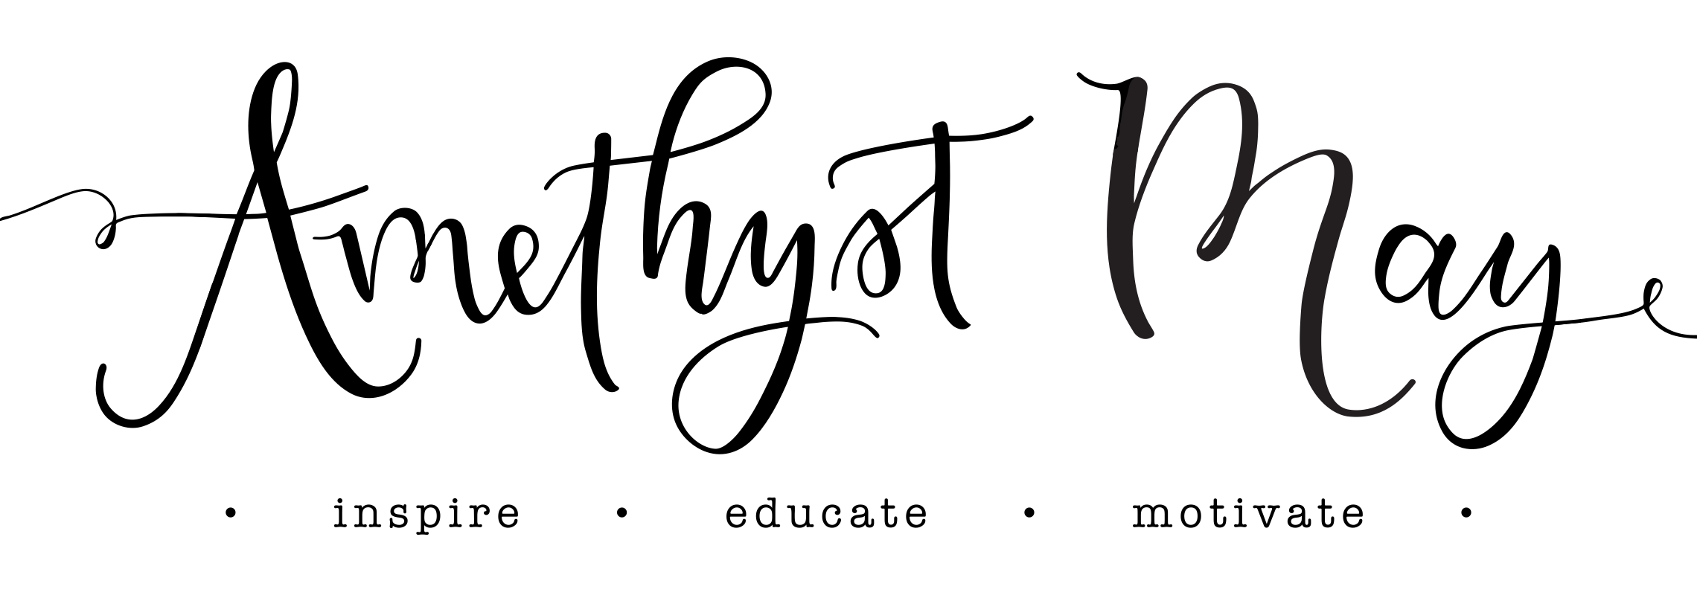

“Parenting in the Digital Age”
Recommended Resources

Top 10 Lists:

Top 10 things you can do TODAY to protect your child:

1. Set up parental controls on your child’s personal devices
2. Disable Internet on your child’s hand held devices
3. Disable location services on all devices
4. Keep your family and/or your child’s computer in a common area
5. Check the history on all devices
6. Change all device passwords (Apple ID or password for Playstore)
7. Check privacy settings set on all social media
8. Create a charging station in a common area at night time
9. Create Device Free Zones
10. Be open and TALK about these issues

Top 10 things you can do THIS WEEK to protect your child:
1. Enforce NO screens behind closed doors rule
2. Provide a charging station for your kids’ friends’ devices
3. Set up parental controls on all family members’ computers
4. Set up parental controls on your TV/Cable device
5. Determine what kind of filter you will use to protect your entire family
6. Set up a family meeting
7. Discuss the Online Family Contract
8. Role play difficult situations
9. Be a positive role model
10. Don’t use empty threats

Filters:
(There are hundreds of filters to choose from. Listed below are some suggestions that are highly rated, but please do your own research to find what works best for your family.)

- Our Pact
A simple family locator and parental control app that allows parents to locate family members and limit screen time by blocking internet and app access for
$0-5/month.
www.ourpact.com

- Safe Eyes
(Protects Mac and PC for $49.95/year up to 3 computers)
http://www.internetsafety.com/safe-eyes-parental-control-software.php

- MM Guardian
Many management options. $49.99 one time fee for iPhone/iPad or $19.99 for 12 mos. $49. For Android: $49.99 one time for phone or $1.99/mo for for tablet & $3.99/mo for phone.
www.mmguardian.com

- Circle with Disney
Manages every device on your network in your home. One time fee of $99. No monthly costs. OR Circle Go for managing devices on the go for $4.99/mo.
www.meetcircle.com

- X3 Watch
($6.99/mo: Accountability Filter; unlimited accountability partners, block pornographic content, customize sites to block or allow, all devices)
http://x3watch.com/

- Mobicip
(Parental Control App: $0-40 per year for up to 5 devices)
http://www.mobicip.com/parental-controls/iphone

- Net Nanny
($5-100 to protect 1-15 devices)
http://www.netnanny.com/l/focusonthefamily/

- My Mobile Watchdog Parental Control App
($4.95/mo: See what your child is doing on their phone, setup time limits, app blocking, and alerts)
http://www.mymobilewatchdog.com/

- Samsung/Android Filters:
-Kids Mode app (set time limits, monitor activity, set up restrictions by age)
-Kids Place (child friendly apps)
-Perfect App Protector (for apps)
-Norton Online Family (controls online)
-Phone Control (controls everything)
-Safe Browser (websites, social networking, spam)

Online Resources:
- Wait until 8th
Take a pledge to wait until the 8th grade to give your child a Smartphone and learn why you should
www.waituntil8th.org

- iParent.tv
Learn about apps, social media, devices and more. Videos are available to watch for most apps, making them easier to understand.

- Screenagers Movie and Tech Talk Tuesdays
Subscribe to weekly emails to encourage conversation at the dinner table
https://www.screenagersmovie.com/tech-talk-tuesdays/

- Family Online Safety Institute
www.fosi.org

- Common Sense Media
-Reviews for all media
www.commonsensemedia.org

- Fight the New Drug
Information about the danger of pornography
www.fightthenewdrug.org

Articles on Prevention/Protection:

- Apps:
http://www.checkupnewsroom.com/7-dangerous-apps-that-parents-need-to-know-about/

https://www.commonsensemedia.org/blog/15-apps-and-websites-kids-are-heading-to-after-facebook

- Pornography:

-Get a free E-book/download of the short read, “Your Brain on Porn” (sheds light on why this is an issue we want to understand, be aware of, and try to safeguard our children from) http://www.covenanteyes.com/brain-ebook/

-Article “What to do if my child is looking at porn” http://www.covenanteyes.com/2012/05/24/what-to-do-if-my-child-is-looking-at-porn-5-critical-steps/

- Parenting/Awareness:

-Blog Post: “To the Well Intentioned but Ignorant Parents of Teenagers”: https://cutestpkever.wordpress.com/2015/03/27/to-the-well-intentioned-but-ignorant-parents-of-teenagers/

Books:

- “American Girls: Social Media and the Secret Lives of Teenagers” by Nancy Jo
Sales
- “lol…OMG” by Matt Ivester
- “iGen” by Jean M. Twenge, PhD
- “Good Pictures, Bad Pictures: Porn-Proofing Today’s Young Kids” by Debbie Fox and Gail Poyner
- “Good Pictures, Bad Pictures Jr: A Simple Plan to Protect Young Minds” by Kristen Jenson and Debbie Fox

